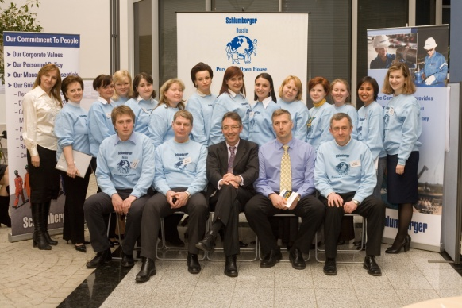



**INTERNATIONAL OPPORTUNITIES FOR MOST PROMISING EMPLOYEES**

Schlumberger has an interesting story to tell of international experience for most promising employees in HR field.

Since the early 20s, Schlumberger has pushed geographical and intellectual frontiers in pursuit of delivery the right level of service quality to our employees. Without smart guys from Personnel that would not mean much. Therefore, a lot of time and effort is spent on development and career planning in Personnel function.

First years in personnel department are defined by a lot of responsibility, accompanied by a fixed step training program. It takes a special kind of person to be successful in Schlumberger: You should be passionate about using your qualification in a practical context to enhance service delivery for the employees. You’ll understand the enormous value of working in a team, alongside the men and women from very diverse backgrounds and cultures.

Your intellectual curiosity is paralleled by our commitment to formal HR training as well as soft skills training. The internal training program structure encourages your proactive involvement in planning and managing your learning program. The program is driven by competencies that are complemented by key formal training seminars throughout the fixed-step program. Competency management provides clear career progression opportunities for you, and efficient skill identification and resource planning for the company.

 We promote from within, based on merit, and depending on your drive and performance, you can achieve great success. We use the term “borderless careers” because we impose no boundaries on geography, department, function, or rate of progression.

Curious how it all works in real life? Let’s look closer at guys from Personnel.

In 2001 Sergey graduated from State University of Management in Moscow. Sergey joined Schlumberger as employee services administrator. It was necessary to respond to queries from employees, perform such actions as hiring, promotion, transfer, termination. In a year, Sergey was working as payroll support expert in Brussels, Belgium. New assignment came in 2004. Position was in Dubai. In several years Sergey returned to Russia, where worked initially in Moscow, then in Tyumen. From 2010 Sergey works in Doha, Qatar as country personnel manager.

Julia started to work at Schlumberger 13 years ago in Moscow. In several years Julia became personnel manager. She took full responsibility for all personnel issues and in Moscow, Saint-Petersburg, Kiev, Almaty. Julia dealt with salary scales creation, benefits policy development, medical and life insurance programs implementation. In 2003 she was transferred in Paris, France. Then Julia went to Dubai. After 3 years of work in United Arab Emirates, position in Bangkok was offered. In 2009 Julia came to Doha, Qatar. Current place of work is Personnel Director in one of companies, belonging to Schlumberger group in Moscow.

It is probably fair to say that Schlumberger is a good place to build you career and our HR professionals are well recognized and sought after in the industry. One of the secret ingredients in that receipe is the early responsibility that we give to people that really shapes an interesting crowd of young managers. Another ingredient is our learning and development programs.